Marketing Toolkit – Demolition San Antonio
Thank you for exhibiting at Demolition San Antonio. The purpose of this toolkit is to provide you resources to help promote your participation at the upcoming Demolition San Antonio. We appreciate your support and look forward to a great event! If you have any questions about the toolkit, please contact Taylor Collison via email at tcollison@demolitionassociation.com
- Web Content
- Social Media
- Sample Email
- Email Signature
- Onsite Photography/Videography/Drone

Web Content
Web Banner
Add the following web banner to any appropriate high-profile page on your company’s website/blog to promote the event. This banner is also usable with social media, email communications, etc. Additional sizes are available. When possible, link the web banner to the Demolition San Antonio homepage here: www.demolitionassociation.com/convention

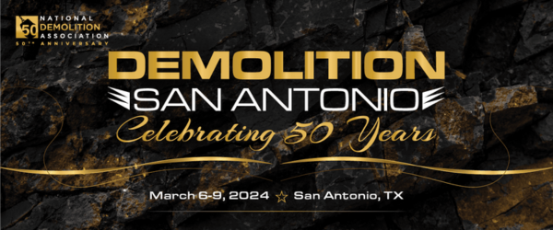
Web Copy
Use the copy below to promote the event on your website, tailoring depending on the page and area of your website. Can’t use all the copy below? Just use the abbreviated listing below.
Event Description: Join NDA and [Company Name] at Demolition San Antonio March 6-9, 2024. This year’s event will reconnect professionals as the industry gets back to work in earnest. Featuring the ever-popular Live DEMOlition Event™, fast and furious presentations, and education from industry leaders, the Annual Convention and Expo is more than just networking. Don’t miss [Company Name] in the Expo to access our range of products and service offerings that can help you add efficiency, capture new opportunities, and increase profits.
Visit the NDA website to learn more about Demolition San Antonio and register today!
Abbreviated Event Details:
Demolition San Antonio
March 6-9, 2024
San Antonio, TX
www.demolitionassociation.com/convention

Social Media
The following social media posts are recommendations but can be tailored to your company’s voice and depending on the platform/account you are posting on. You can also draft your own! Consider using the web banner above as well.
Facebook / LinkedIn:
Join the National Demolition Association for #DemolitionSanAntonio! Visit [Company name] at [booth #] in the Expo. Register today and we’ll see you there! https://www.demolitionassociation.com/Education-Events/Demolition-San-Antonio/Registration
[Company name] and other industry leading companies will be in attendance at #DemolitionSanAntonio – will you? Register to join us and the National Demolition Association in San Antonio March 6-9! https://www.demolitionassociation.com/Education-Events/Demolition-San-Antonio/Registration
[Company name] is exhibiting at Demolition San Antonio. Register and stop by the Expo at [booth #] to learn more about our latest products and services! https://www.demolitionassociation.com/Education-Events/Demolition-San-Antonio/Registration
Visit us at our booth in the Expo at #DemolitionSanAntonio, your one-stop-shop for all things demolition. The National Demolition Association is connecting our industry and we’re excited to participate in San Antonio. Find the full schedule on the event website and join us. https://www.demolitionassociation.com/Education-Events/Demolition-San-Antonio/Schedule
As 2024 approaches, it’s more important than ever to connect with each other and stay up to date on the latest products and services to help your company work more effectively, save more money, and keep employees safe. NDA’s #DemolitionSanAntonio is the perfect place to gain that knowledge. [Company name] is exhibiting and featuring [products, services, etc.] – this is a can’t-miss event, so register today! https://www.demolitionassociation.com/Education-Events/Demolition-San-Antonio/Registration
What can you expect at #DemolitionSanAntonio? Leading manufacturers and suppliers, including [Company name], will provide one-stop access to the latest technologies and tools to help your business. Register today and visit our booth in San Antonio! https://www.demolitionassociation.com/Education-Events/Demolition-San-Antonio/Registration
Facebook and LinkedIn Tips:
- In addition to sharing a post on your own Facebook timeline and LinkedIn profile, consider posting in a related group you belong to. Be sure to abide by group policy.
- Adding your own customization can go a long way towards ensuring that your post is read and not considered spam. Consider adding a personal message, including a related photo.
- Don’t forget to tag the NDA Facebook page or LinkedIn page!

X (formerly Twitter):
Register for #DemolitionSanAntonio as @NDAMakingWay reconnects the industry, March 6-9. Stop by [booth #] in the Expo to learn more about our latest products. Learn more: https://bit.ly/47s8c2K
Join [Company name] at #DemolitionSanAntonio March 6-9! [Company name] will be exhibiting and featuring [products, services, etc.]. Learn more: https://bit.ly/47s8c2K
Don’t miss out on @NDAMakingWay’s #DemolitionSanAntonio – the industry is connecting industry leaders! [Company name] will be exhibiting and hope to see you there. Learn more: https://bit.ly/47s8c2K
Why do we attend @NDAMakingWay’s Annual Convention and Expo? [ideas: the Live DEMOition Event™, fast-and-furious education sessions, the industry-leading exhibitors, connecting with colleagues from across the country]. Register to join us at #DemolitionSanAntonio March 6-9! https://bit.ly/47s8c2K
What can you expect at #DemolitionSanAntonio? Leading manufacturers and suppliers like [Company name] will provide one-stop access to the latest technologies and tools to help your business. Register to join us in San Antonio! https://bit.ly/47s8c2K
At #DemolitionSanAntonio, learn how to help your company work more effectively, save more money, and keep employees safe. [Company name] will be exhibiting our latest products and services that help you do just that. Register to join today! https://bit.ly/47s8c2K
X Tips:
- Posts have a maximum length of 280 characters, including URLs, hashtags and punctuation. Be direct and succinct.
- Use URL shorteners whenever possible.
- Use the event hashtag: #DemolitionSanAntonio in your Tweets.
- Add any relevant and active industry hashtags to (i.e. #demolition #demolitionindustryevents)
- Remember to diversify your posts. Spamming the same Tweet can generate a negative reaction from the community.
- Avoid posting at early or late hours of the day. During normal business hours is preferred and ideal.
- Follow and tag NDA’s Twitter account (@NDAMakingWay) for additional engagement opportunities.

Email
Below is a sample email you can use to reach out to professional contacts in the industry to help spread the word about Demolition San Antonio and invite them to attend. We recommend you tailor this to your own voice and personal style where applicable so that it does not feel like spam to your contact.
[Subject]: Join [me/company name] at Demolition San Antonio!
[Body]
Dear <name>,
I’m excited that [company name] will join the National Demolition Association at their Annual Convention and Expo. Demolition San Antonio is taking place March 6-9 and I’d love to see you join us too. As you know, our industry plays a critical role in communities everywhere and this gathering will give us the chance to learn about how to do so safely, efficiently and more.
Event highlights include:
- The ever-popular Live DEMOlition Event™;
- Best in class education content to help take your business to another level;
- Leading exhibitors including [company name] in the Expo;
- Hands-on, interactive learning with equipment; and
- Opportunities to develop and strengthen relationships with industry colleagues.
I can’t recommend Demolition San Antonio enough, at a time when it’s needed most. Visit us in the Expo as we’re showcasing [insert products, services].
You can learn more about registration here and we hope to see you in San Antonio!
[Signature]
Email Signature
Consider adding the banner below to your email signature in order to increase awareness of your attendance at Demolition San Antonio with your professional contacts. You can use the template below or customize your current signature by adding the image/banner. Remember to link the image to www.demolitionassociation.com/convention

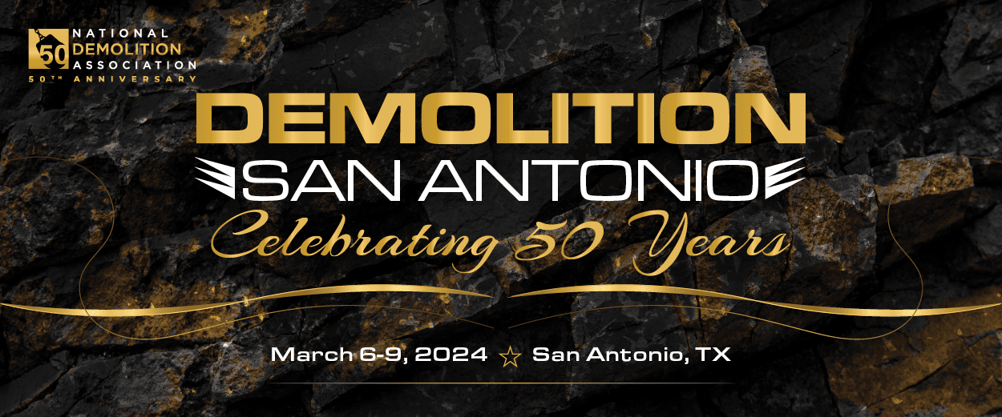
Name
Title | Company
Address 1, Address 2 | City, State Zip
P: +1.XXX.XXX.XXXX | E: email@email.com

Onsite Photography/Videography/Drone
Continue to market your products and brand after Demolition San Antonio by booking a session with our exclusive event photographer, Roosed Media. Submit the Photography/Videography/Drone order form asap as session spots are limited. Please note, personal drones are not permitted at the Live DEMOlition Event™. Orders must be paid in full prior to your shoot via check or credit card.

Questions? Email Eric@roosedmedia.com

